# INTRODUCTION TO PROJECT

The web based “OnlineShopping System” project is an attempt to make revolutionary changes in shoppingCulture,this project is a full-featured website and shopping cart system that bends over backwards to give you the flexibility you need to run your online store.

The basic concept of the application is to allow the customer to shop virtually using the Internet and allow customers to buy the s items of their desire from the store. The system enables the customer to do the things such assearching the product, cart functionality, payment functionality, etc. The system provides you Quick Search facility that provides you details about product without login . But if user want to buy product then it must require login into your account. The system allows the user to search for productby category. Here we provided quick search facility which displays list of available Product and allows customer to choose a particular Product. Then the system checks for the availability of product. If the product are available then the system permit the customer to make shopping .Otherwise it shows the customer product is out of stock.To make shopping, the system asks the customer to enter his details such as name, address, city, stateand contact number.

The information pertaining to the products are stores on an RDBMS at the server side (store). The Server process the customers and the items are shipped to the address submitted by them.

The details of the items are brought forward from the database for the customer view based on the selection through the menu and the database of all the products are updated at the end of each transaction

The application design contains three modules one is for the customers who wish to buy the items. Second is for the store owners who maintains and updates the information regarding the items and about the customers. And, third is for the vendors who will provide the items to admin for further distribution to customers.

The end user to use this product are the common people for whom the application is to be hosted on the web and the admin maintains the database.

# REQUIREMENTS

## Functional Requirement:

### USER REQUIREMENTS



#### User Account

The customer, who will henceforth be called the ‘user’, will be presented with 3 choices by the shopping system, as the first step in the interaction between them. A user can choose one of these and his choice would be governed by whether he is a guest or a registered user and whether he wants to check the availability of product or also buy them. The terms ‘registered user’ and ‘guest’ are described below.

A user who has shopped by the our site earlier would have been given a user id and a password. This ‘personal information’ would be henceforth referred to as ‘profile’. Such a user with a profile in DB-user shall be called a ‘registered user’. A registered user will be able to check the availability of the product as well as buy a product by logging into the system.

A new user, on the other hand, would either have to

1. register himself with the system by providing personal information or
2. log into the system as a guest.

In case of first choice, the new user becomes a registered user. In case of alternative option, the new user would remain a guest.

A guest can only check the availability of the product and cannot buy product.But a registered user can also act as a guest if he only wants to check the availability of product.

‘Availability of the product’ always refers to viewing the stock quantity for given time. The system shall present the user with an option to exit from the system at any time during the following processes.

#### Registration and creation of user profile

The system shall require a user to register, in order to carry on shopping. It will ask the user for the following information at the least –password, name, email address. The system will automatically create a ‘sky miles’ field and initialize it to zero in the user’s profile.



#### Quick Search

Here we provided Quick Search facility for any user to search product without login

into account. This will provide user an option for searching product and comparing their prices of all companies.

After logging in a user (either a registered user or a guest), the system shall

request him to enter the following details, Product name then onward, Page Navigation

directed towards product page. The system shall now ask the user to enter the following

details – quantity.

#### Edit Profile

Profile edit functionality provide facility to change the name, phone number, and password if at any point user wanted to change it for his personal reasons.

#### Cart

Once quick search is done, and desired product has been found out, then customer is have facility to add product into cart, and again have choice to go on to the quick search, home or payment. But quick search is available for register user only.

#### Review

Once Product has been delivered to the user our site give facility to review the product so that next user whoever going to buy our product is getting option to choice best option as per previous customer review.

#### Payment

User are now one step behind from his happiness to his E-Shopping completion. Here user use credit, debit card for payment to be done on our site, so once payment has been done then he is ensure that no worry product will be deliver to him regardless of stock will end at next movement.

### ADMIN REQUIREMENTS



#### 2.1.1 User Account

The Owner of our website, who will henceforth be called as the ‘Admin’, will be presented with different choices over theshopping system, as the first step in the interaction between them. Aadmin can choose one of these and his choice would be directed by his work or else he is default directed on home page.

Admin have completed control over the shopping system, he can see product details, seller details, control over seller and users all activity.

#### Login

User have default account presented, so he only need to login with his email id and password. Once he successfully done login he has three page Home, About, Dashboard, Logout.

#### Quick Search

Here we provided Quick Search facility for any Admin also to search product without logininto account. This will provide user an option for searching product.

After logging in a Admin, if he also want to buy from system, the system shall

request him to enter the following details, Product name then onward, Page Navigation

directed towards product page. The system shall now ask the user to enter the following

details – quantity.

#### Edit Profile

Profile edit functionality also provide to admin to change the name, phone number, and password of his himself ,User or seller. if at any point Admin wanted to change it for any business reasons.

#### Cart

Once quick search is done, and desired product has been found out by Admin, then he is have facility to add product into cart, and again have choice to go on to the quick search, home or payment.

#### Review

Admin have facility to review the product so that next user whoever going to buy our product is getting option to choice best option as per previousreview.

#### Payment

Admin are now one step behind from his happiness to his E-Shopping completion from his own site. Here user use credit, debit card for payment to be done on his site, so once payment has been done then he is ensure that no worry product will be deliver to him regardless of stock will end at next movement.

#### Manage User

Admin have full control over every activity of user, activity such as,

* admin can approve the user
* can suspend user

#### Customer Details

Admin can overall see each individual details of customer except password which is save in encrypted format. Otherwise each individual detail will be present at Customer so he can better control over online system

#### View Product

Product details with their brand name will be accessible by Admin, he can get to know details of stock of that product, the seller details who are going to sell it to customer, the order already delivered to customer by whom. This kind of details admin can get through View Product.

### SELLER REQUIREMENTS



#### 2.1.1 User Account

The person who will going to sell his product is henceforth be called the ‘Seller’, will be presented with different choices by the shopping system, as the first step in the interaction between them. A Sellercan choose one of these and his choice would be directed by his work or else he is default directed on home page.

A user who has selled by our site earlier would have been given a user id and a password. This ‘personal information’ would be henceforth referred to as ‘Seller profile’. Such a user with a profile in DB-user shall be called a ‘registered Seller’. A registered Seller will be able to check the product order as well as buy a product by logging into the system.

A new user, on the other hand, would either have to

1. register himself with the system by providing personal information or
2. log into the system as a guest.

In case of first choice, the new user becomes a registered user. In case of alternative option, the new user would remain a guest.

A guest can only check the availability of the product and cannot Sellproduct.But a registered user can also act as a guest if he only wants to check the availability of product.

‘Availability of the product’ always refers to viewing the stock quantity for given time. The system shall present the Seller with an option to exit from the system at any time during the following processes.

#### 2.1.2 Registration and creation of user profile

The system shall require a Seller to register, in order toSell on shopping site. It will ask the user for the following information at the least –password, name, email address. The system will automatically create a ‘sky miles’ field and initialize it to zero in the Seller’s profile.



Seller

#### Quick Search

Herewe providedQuickSearchfacility for any Seller to search his own product after logininto account. This will provide seller an option for easily getting status of his own product.

#### Edit Profile

Profile edit functionality provide facility to change the name, phone number, and password if at any point Seller wanted to change it for his personal reasons.

#### Add New Product

Seller have full authority to launch new product on online store. He only need to insert brand, quantity, image, product description on store platform.

#### Update Product details

If for any certain reasons seller want to update his own product, product quantity, product description, he has full control over it. He can done easily by simple login.

#### Cancel Product

If for any certain reasons like product out of stock, product is not as per required quality, seller want to cancel his own product order, he has full control over it. He can done easily by simple login.

## NON FUNCTIONAL REQUIREMENTS

**2.2.1 Interface**

Go to Appendix B for user interfaces

**2.2.2 Performance**

* **Number of Concurrent Users:**

Online shopping shall be able to handle at least 1000 transactions/inquiries persecond

**2.2.3 Constraint**

Online shopping shall be able to handle at least 1000 transactions/inquiries persecond

**2.2.4 Other Requirements:**

* **Hardware Interfaces**

The SPMS is expected to function on Intel PIII 900 MHz Processor equivalent or above, 128 MB RAM, 20 GB HDD.

* **Software Interfaces**

The SPMS shall work on MS Windows operating systems family (MS Windows 98, MS Windows NT Workstation, MS Windows 2000, MS Windows XP). It configures to work with Oracle database. This System works on Apache Tomcat server. It uses browser IE 5.0 & above. It uses IIS 5.0 server.

1. **D**ESIGN

**3.1 Database Design**

The following table structures depict the database design.

# Table 1: Category

|  |  |  |
| --- | --- | --- |
| cat_id | cat_title | cat_description |
|  |  |  |

## **Table 2: Address**

|  |  |  |  |  |  |  |
| --- | --- | --- | --- | --- | --- | --- |
| **add_id** | **user_id** | **address** | **city** | **state** | **country** | **pin** |
|  |  |  |  |  |  |  |

# Table 3: Company

|  |  |  |
| --- | --- | --- |
| **comp_id** | **comp_title** | **comp_description** |
|  |  |  |

### Table 4: Myorder

|  |  |  |  |  |  |
| --- | --- | --- | --- | --- | --- |
| **myorder_id** | **user_id** | **orderDate** | **status** | **total_price** | **add_id** |
| 1 | 11 | 1 | 1 | 1 | 1 |

**Table 5: OrderDetails**

|  |  |  |  |  |  |  |
| --- | --- | --- | --- | --- | --- | --- |
| **orderdetails_id** | **myorder_id** | **Product_id** | **price** | **quantity** | **rating** | **comment** |
|  |  |  |  |  |  |  |

### Table 6:Product

|  |  |  |  |  |  |  |  |  |
| --- | --- | --- | --- | --- | --- | --- | --- | --- |
| Prod_id | Prod_title | Prod_desc | Prod_price | cat_id | Comp_id | Prod_qty | Seller_id | photo |
|  |  |  |  |  |  |  |  |  |

### Table 7:User

|  |  |  |  |  |  |  |
| --- | --- | --- | --- | --- | --- | --- |
| **user_id** | **User_name** | **User_phone** | **User_email** | **User_password** | **User_status** | **User_role** |
|  |  |  |  |  |  |  |

### Table 8:Payment

|  |  |  |  |  |  |
| --- | --- | --- | --- | --- | --- |
| **myorder_id** | **user_id** | **orderDate** | **status** | **total_price** | **add_id** |
| 1 | 11 | 1 | 1 | 1 | 1 |

### Table 9: Cart

|  |  |  |  |
| --- | --- | --- | --- |
| **cat_id** | **user_id** | **Prod_id** | **Cart_qty** |
| 1 | 11 | 1 | 1 |

1. CODING STANDARDS IMPLEMENTED

### Naming and Capitalization

Below summarizes the naming recommendations for identifiers in Pascal casing is used mainly (i.e. capitalize first letter of each word) with camel casing (capitalize each word except for the first one) being used in certain circumstances.

|  |  |  |  |
| --- | --- | --- | --- |
| **Identifier** | **Case** | **Examples** | **Additional Notes** |
| Class | Pascal | Person, BankVault, SMSMessage, Dept | Class names should be based on "objects" or "real things" and should generally be **nouns**. No ‘_’ signs allowed. Do not use type prefixes like ‘C’ for class. |
| Method | Camel | getDetails, updateStore | Methods should use **verbs** or verb phrases. |
| Parameter | Camel | personName, bankCode | Use descriptive parameter names. Parameter names should be descriptive enough that the name of the parameter and its type can be used to determine its meaning in most scenarios. |
| Interface | Pascal with "I" prefix | Disposable | Do not use the ‘_’ sign |
| Property | Pascal | ForeColor, BackColor | Use a noun or noun phrase to name properties. |
| Associated private member variable | _camelCase | _foreColor, _backColor | Use underscore camel casing for the private member variables |
| Exception Class | Pascal with "Exception" suffix | WebException, |  |

### Comments

* Comment each type, each non-public type member, and each region declaration.
* Use end-line comments only on variable declaration lines. End-line comments are comments that follow code on a single line.
* Separate comments from comment delimiters (apostrophe) or // with one space.
* Begin the comment text with an uppercase letter.
* End the comment with a period.
* Explain the code; do not repeat it.

1. TEST REPORT

**Another group called Linux did the testing and the report of the testing is given hereunder.**

**GENERAL TESTING:**

|  |  |  |  |  |
| --- | --- | --- | --- | --- |
| **SR-NO** | **TEST CASE** | **EXPECTED RESULT** | **ACTUAL RESULT** | **ERROR MESSAGE** |
| 1 | Registration | Redirected to Next page | OK | Nothing |
| 2 | Login Page | Pop-up will come | Ok | Nothing |
| 3 | Logout | redirected to home page | ok | Nothing |
| 3 | Edit Profile | users password,name,phone will be reseted | Ok | Nothing |
| 4 | Quick search Product | Product is displayed | Ok | Nothing |
| 5 | Add to cart | Product should added in to the cart | Ok | Nothing |
|  | Customer details | list of customer are shown | ok | Nothing |
|  | Payment | Payment successful | Not ok |  |
|  | Update Product | Product Qty has been changed | ok | Nothing |
| 6 | Order details | redirected to order details page | Ok | Nothing |
| 7 | Review | Add informations according to no of seats allocated | Ok | Nothing |
| **STATIC TESTING** | | | | |
| **SR-NO** | **Deviation** | **Program** |  |  |
| 1 | Commenting not followed | All Web Application |  |  |

1. PROJECT MANAGEMENT RELATED STATISTICS

|  |  |  |  |
| --- | --- | --- | --- |
| **DATE** | **WORK PERFORMED** | *SLC Phase* | **Additional Notes** |
| Oct 20,2020 | Project Allotment and User Requirements Gathering | Feasibility Study | Our team met the client Mr. Nitinkudale (CEO, SIIT Pune) to know his requirements. |
| March 8,2021 | Initial SRS Document Validation | Requirement Analysis | The initial SRS was presented to the client to understand his requirements better |
| And Team Structure Decided | (Elicitation) |
| March 9,2021 | Designing the use-cases, Class Diagram, Collaboration Diagram, E-R Diagram and User Interfaces | Requirement Analysis & | Database Design completed |
| Design Phase |
| March 9,2021 | Business Logic Component design Started | Design Phase | ---------------------- |
| March 10,2021 | Coding Phase Started | Coding Phase | 70% of Class Library implemented. |
| March 11,2021 | Implementation of Web Application and Window Application Started | Coding Phase | Class Library Development going on. |
| March 12, 2021 | Implementation of Web Application and Window Application Continued | Coding Phase and Unit Testing | Class Library Modified as per the need. |
|  |
| March 20, 2021 | Implementation of Web Application and Window Application Continued | Coding Phase and Unit Testing | -- |  |
|  |
| March 20, 2021 | After Ensuring Proper Functioning the Required Validations were Implemented | Coding Phase and Unit Testing | Module Integration was done by the Project Manager |  |
| March 20, 2021 | The Project was Tested by the respective Team Leaders and the Project Manager | Testing Phase (Module Testing) | -- |  |
| March 21, 2021 | The Project was Submitted to Other Project Leader of Other Project Group For Testing | Testing Phase (Acceptance Testing) | The Project of Other Team was Taken up by the Team for Testing |  |
| March 21, 2021 | The Errors Found were Removed | Debugging | The Project was complete for submission |  |
|  |
| March 22, 2021 | Final Submission of Project |  |  |  |

# Appendix A

Entity Relationship Diagram

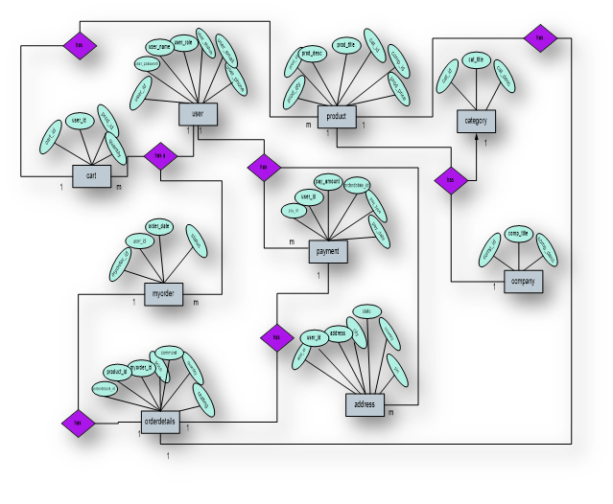

**DataFlow Diagram:**

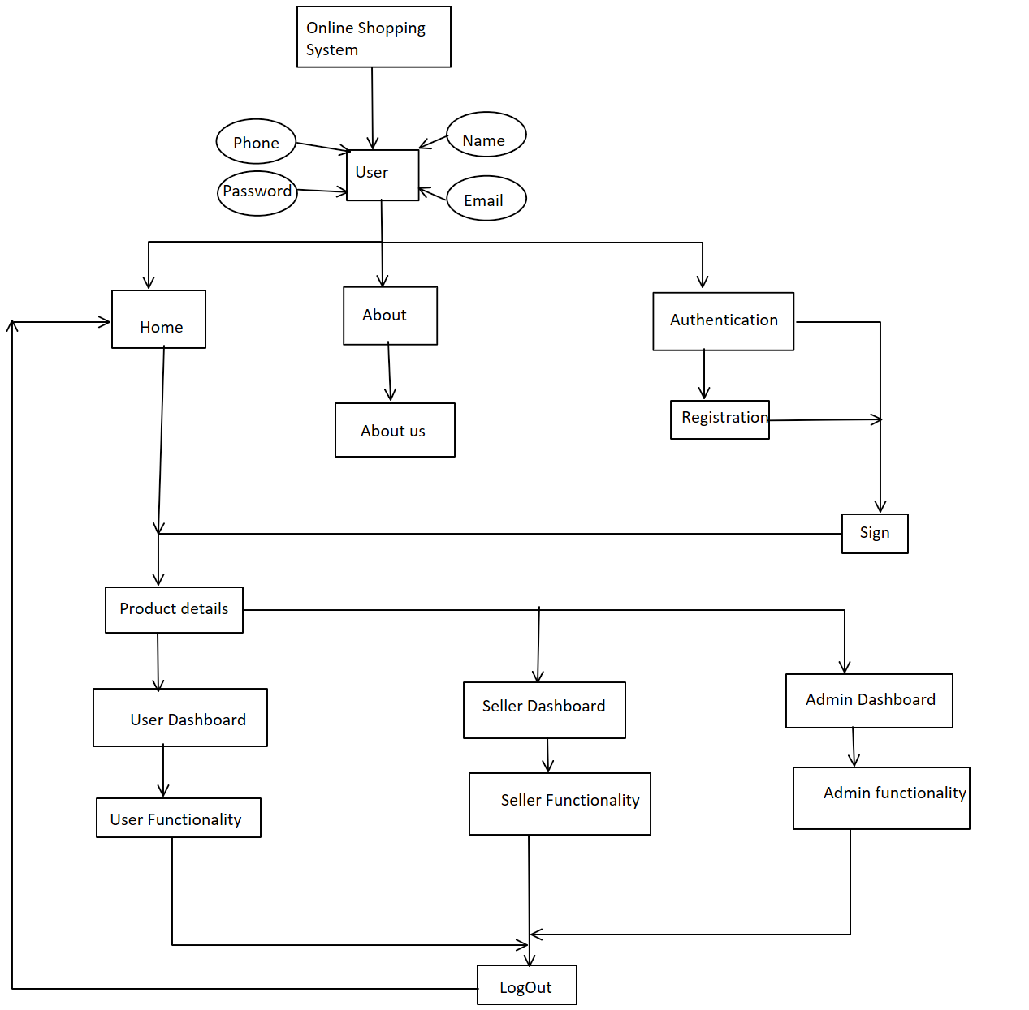

**Class Diagram**

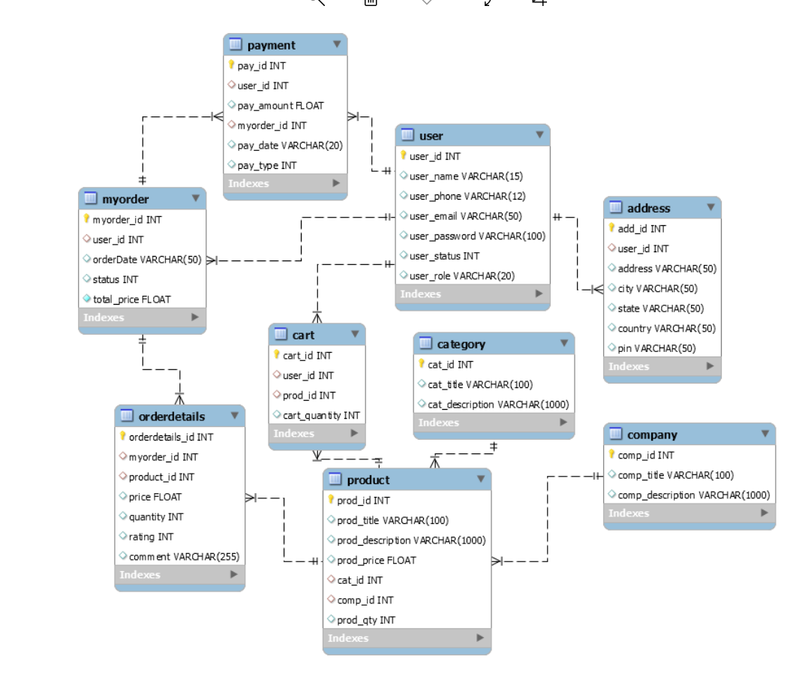

# AppendixB

Signin

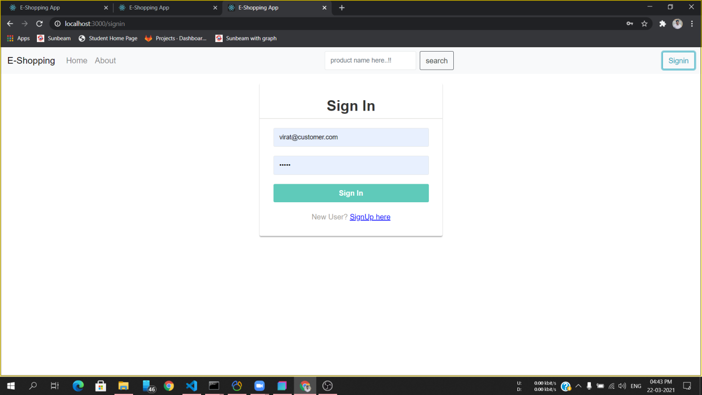

Signup

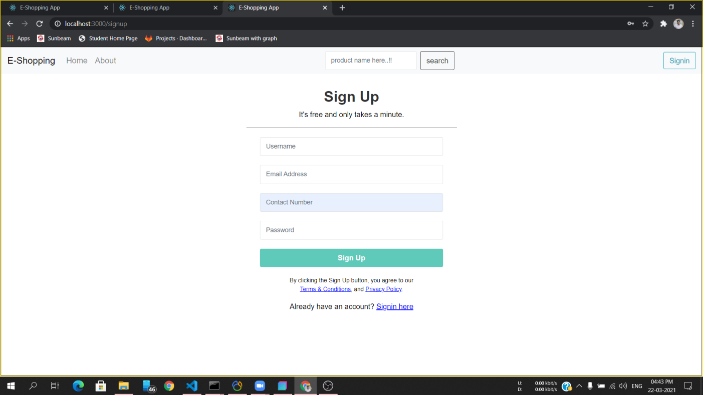

Homepage:

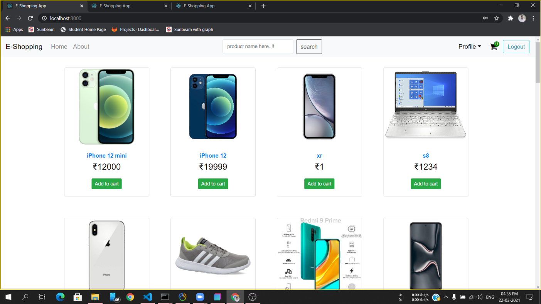

Product Details :

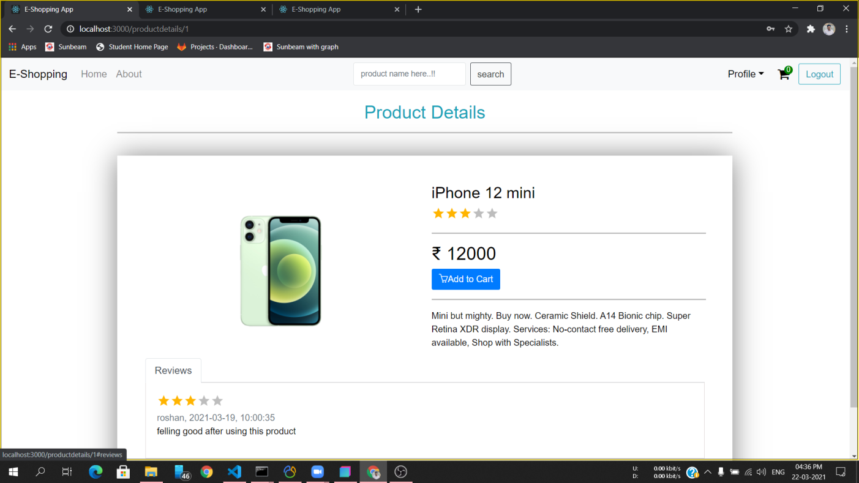

Shopping Cart :

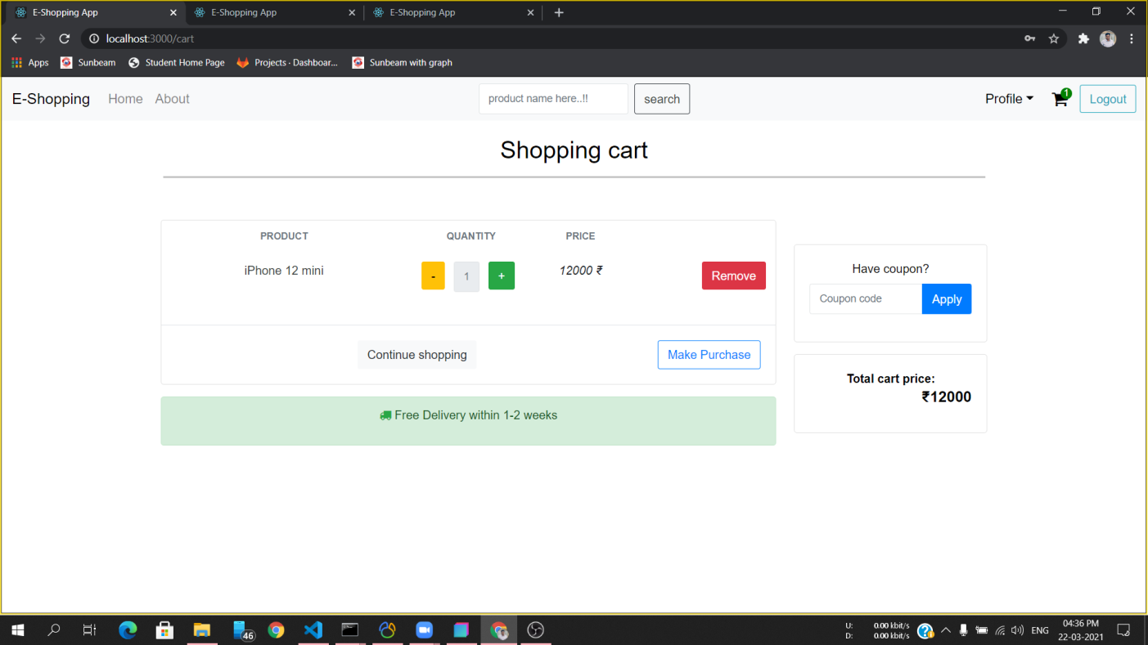

Edit Profile :

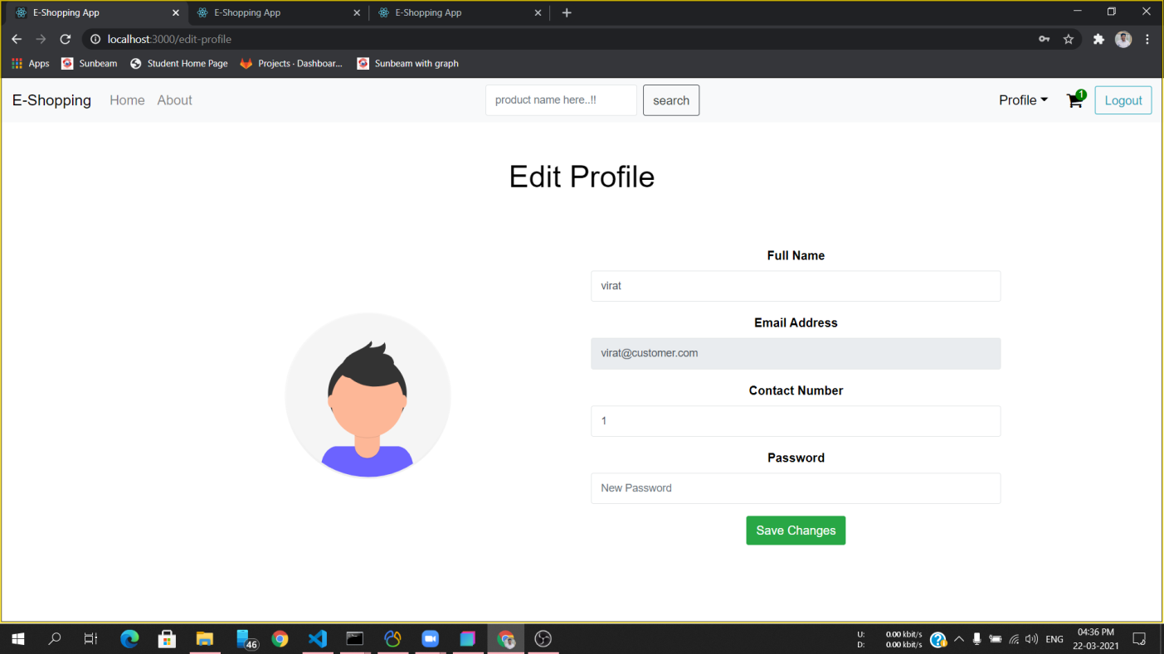

Select Shipping Address Or Add New Address:

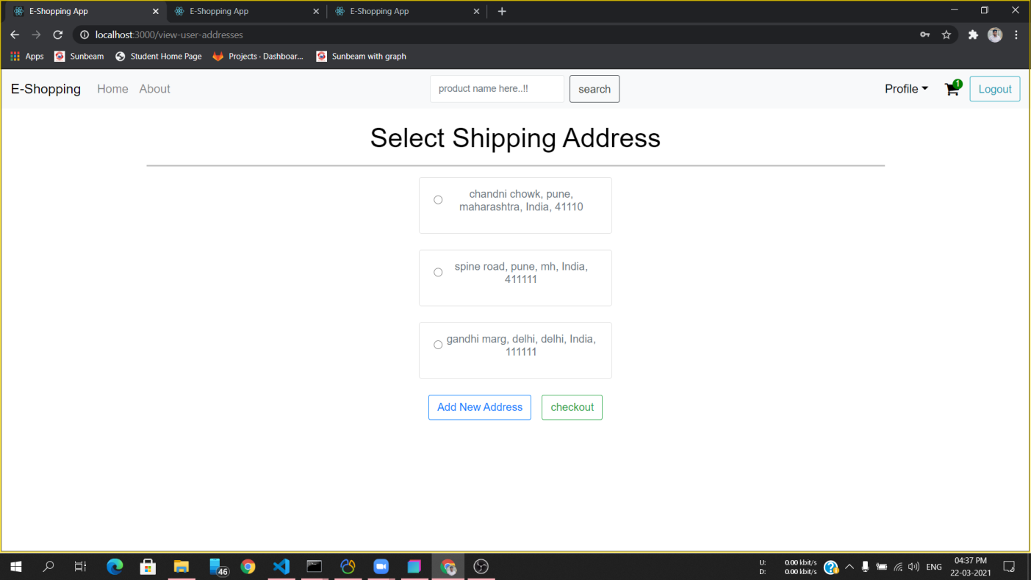

User Order List :

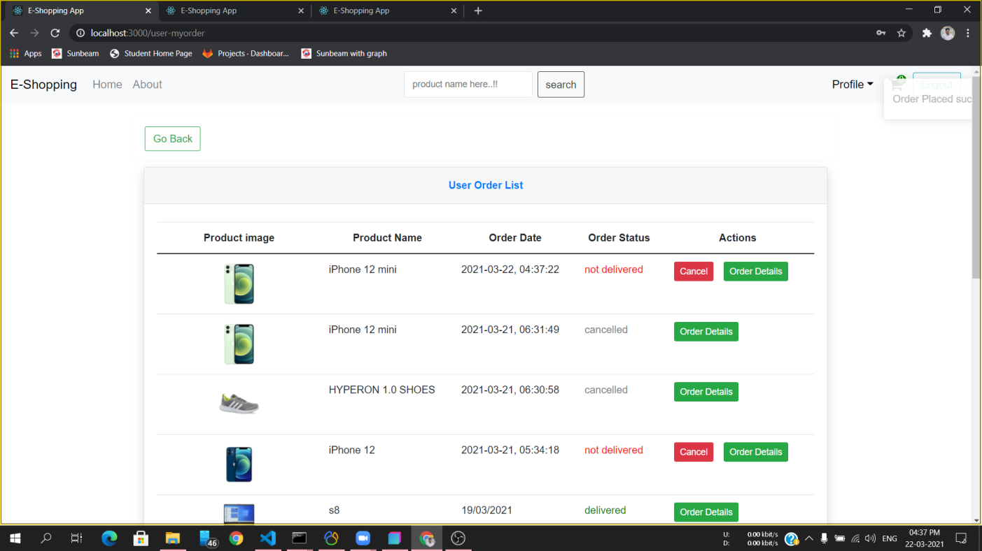

Seller Dashboard:

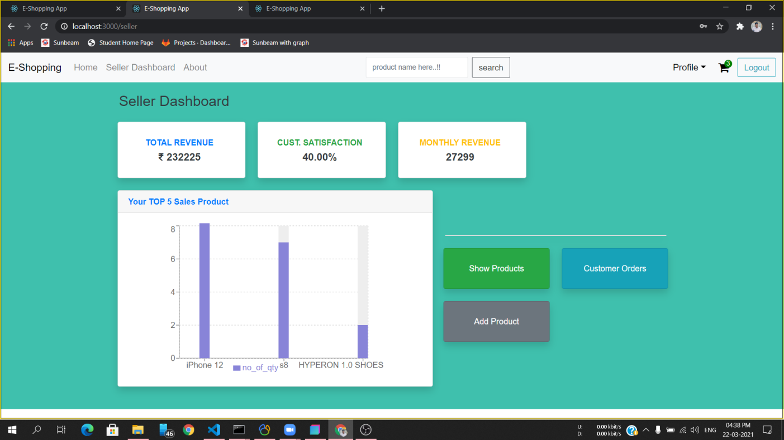

Product List:

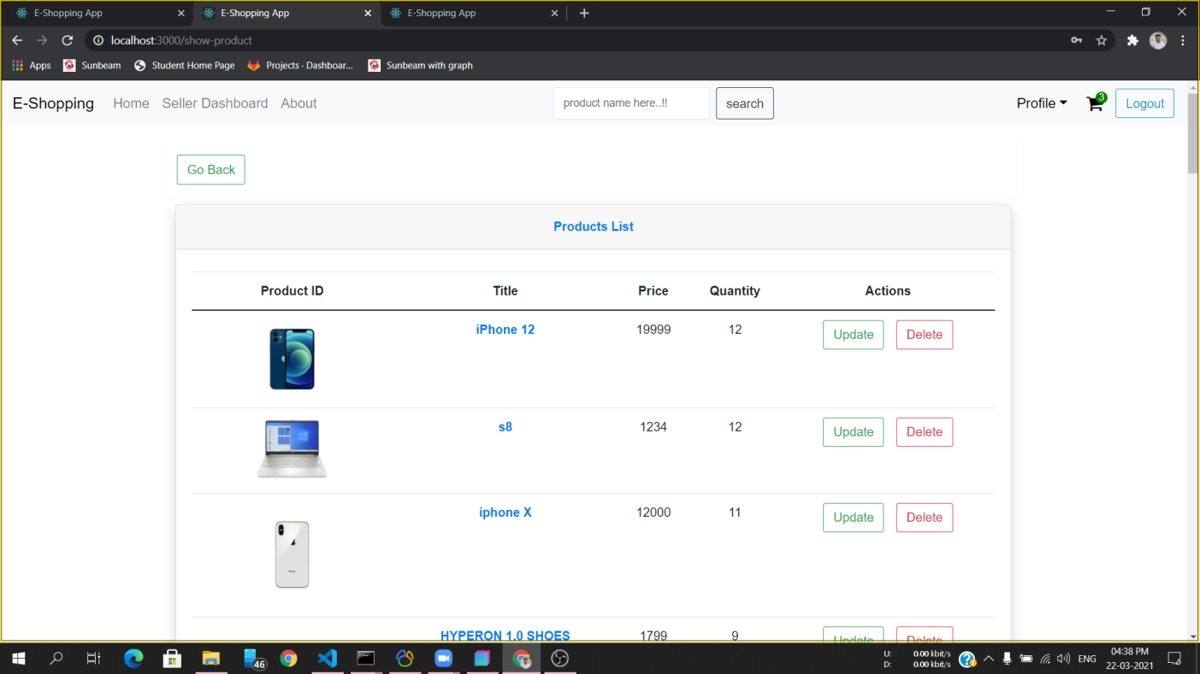

Edit Product Details :

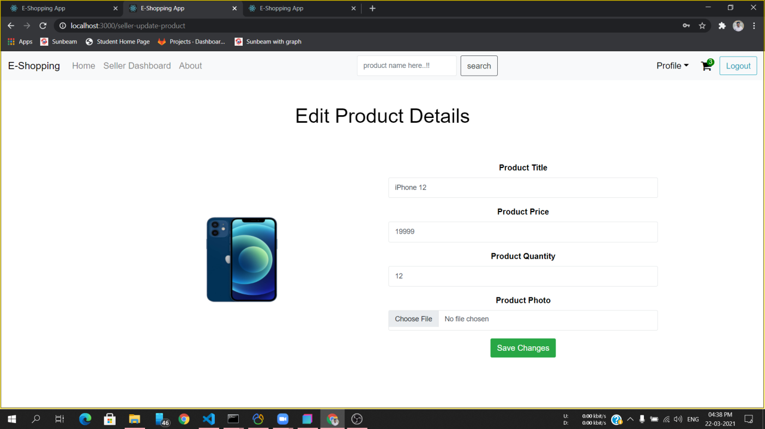

Admin Dashboard :

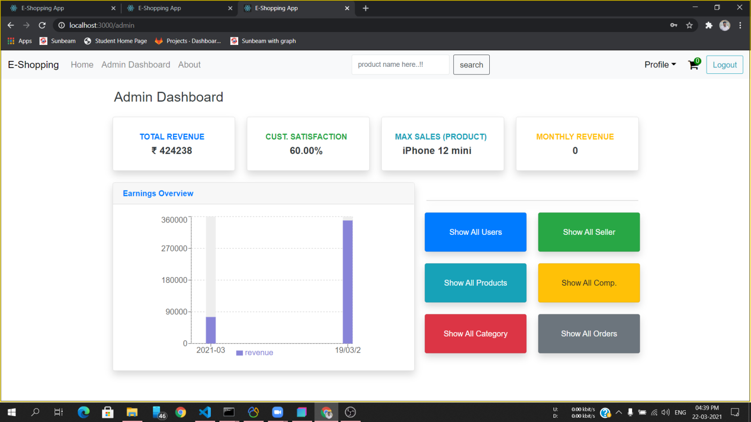

User List For Admin :

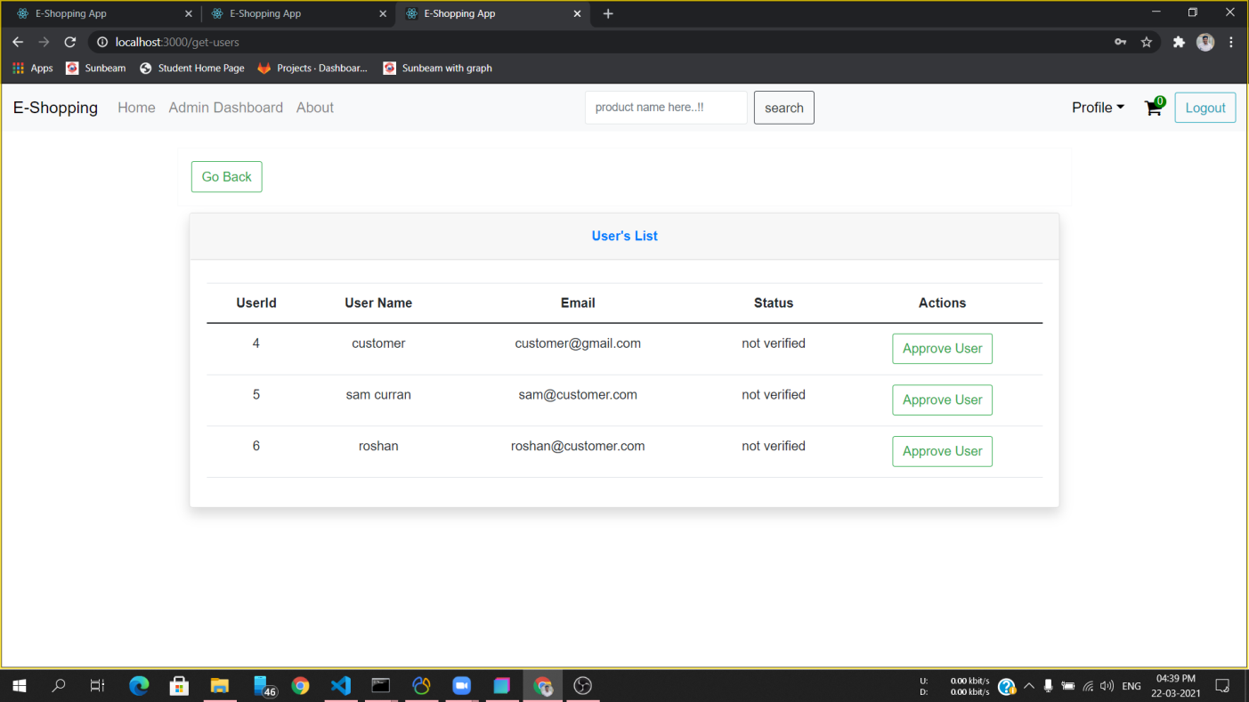

Seller List For Admin :

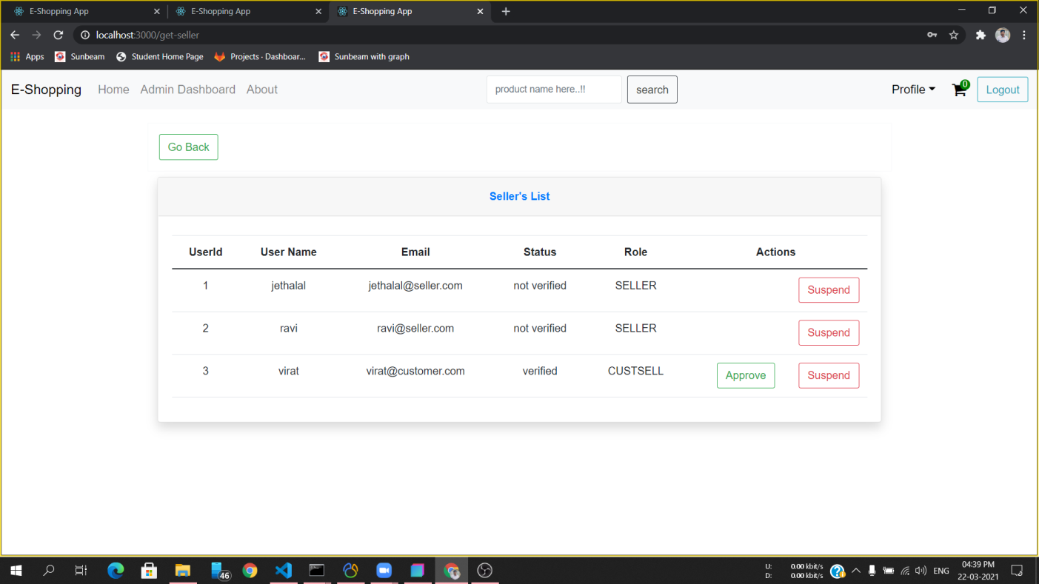

# 7.REFERENCES:

<http://www.google.com>

[http://](http://www.xml101.com:8081/xml/)www.Flipkart.com

http://www.Amazon.com/

http://www.lenskart.com

http://www.snapdeal.com

http://www.GitHub

http://www.Bootstrap.com

<http://www.myntra.com>

http://www.Wikipedia.com